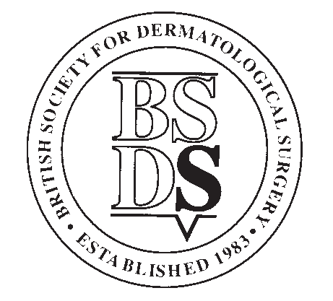

BRITISH SOCIETY FOR DERMATOLOGICAL SURGERY
Medical Student Essay Prize Application Form, January 2026
Applicants Details
Forename
Surname
Year of Study
Contact Address
Post Code
Telephone
Email
Contact details for member of staff at your medical school registry:
Applicants’ student status will be confirmed with the medical school before prize is awarded
Name
Position
Name of Medical School
Email
Telephone

Please see overleaf for conditions of entry.
The closing date for applications is 31st January 2026.
Application forms must be submitted along with your submission file to: info@bsds.org.uk

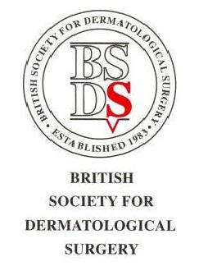

BSDS Medical Student Essay Prize

Conditions

- The BSDS Medical Student Essay Prize is open to any individual who has medical student status at the time of application or who graduates in 2026.

- Posters must be the applicant’s own work and be on the subject determined by the BSDS Executive Committee.

- The submission of a poster to be saved as either a MS Word or MS PowerPoint file only.

- Publication references must be given and will be checked.

- AI tools can be used for research and to assist in forming concise text and effective diagrams and figures, but submissions generated largely or entirely by AI tools will be rejected. AI plagiarism is a significant probity issue, and you will be reported to your medical school if this is detected.

- The use of AI must be declared and the elements of what it has been used for in the submission clearly stipulated.

- Any patient images must be anonymised as much as possible and fully informed publication consent obtained and recorded in the patient records.

- The veracity of the submission must be attested to by the author.

- To apply, applicants should submit their poster and application form to: info@bsds.org.uk

- The deadline for applications will be 31st January 2026 at 11.59pm.

- The prize will be: £300.

- Winners may be invited to give a presentation at one of the BSDS meetings and may have their poster published on the BSDS website.

- Applicants’ student status will be confirmed with the medical school before prize is awarded.

- International students are welcome to apply but must provide proof of student status.

Marking Criteria

Your essay will be judged on the following criteria:

- Content (20)
- Originality (10)
- Style/Structure (10)
- Relevance to Dermatological Surgery (10)

