**BRITISH SOCIETY FOR DERMATOLOGICAL SURGERY**

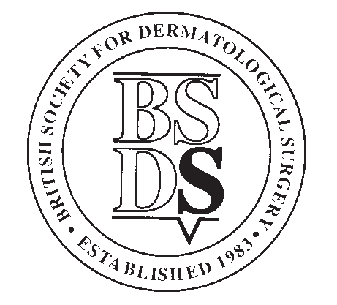

**Medical Student Essay Prize Application Form, July 2025**

**Applicants Details**

|  |  |
| --- | --- |
| **Forename** |  |
| **Surname** |  |
| **Year of Study** |  |
| **Contact Address** |  |
| **Post Code** |  |
| **Telephone** |  |
| **Email** |  |

**Contact details for member of staff at your medical school registry:**

*Applicants’ student status will be confirmed with the medical school before prize is awarded*

|  |  |
| --- | --- |
| **Name** |  |
| **Position** |  |
| **Name of Medical School** |  |
| **Email** |  |
| **Telephone** |  |

Please see overleaf for conditions of entry.

**The closing date for applications is 31st July 2025.**

Application forms must be submitted along with your submission file to: [info@bsds.org.uk](mailto:blake@bad.org.uk)

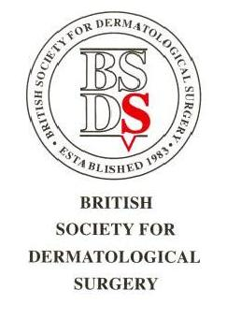

**BSDS Medical Student Essay Prize**

**Conditions**

1. The BSDS Medical Student Essay Prize is open to any individual who has medical student status at the time of application or who graduates in 2025.
2. Essays must be the applicant’s own work and be on the subject determined by the BSDS Executive Committee.
3. Essays should be no longer than **800 words** (excluding tables and references) and should be typed in 12-point size with double line spacing. Please note there should be a maximum of 3 tables and maximum 12 references.

Essays should be submitted electronically in word or another editable and compatible format (Not PDF please).

1. To apply, applicants should submit their essay and application form to: [info@bsds.org.uk](mailto:info@bsds.org.uk)
2. The deadline for applications will be 31st July 2025 at 11.59pm.
3. The prize will be: **£300.**
4. Winners may be invited to give a presentation at one of the BSDS meetings and will have their essay published on the BSDS website and social media.
5. Applicants’ student status will be confirmed with the medical school before prize is awarded.

**Marking Criteria**

**Your essay will be judged on the following criteria:**

* Content (20)
* Originality (10)
* Style/Structure (10)
* Relevance to Dermatological Surgery (10)