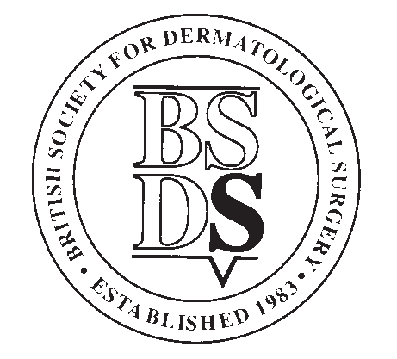
BRITISH SOCIETY FOR DERMATOLOGICAL SURGERY
Medical Student Essay Prize Application Form, July 2024
Applicants Details
Forename
Surname
Year of Study
Contact Address
Post Code
Telephone
Email
Contact details for member of staff at your medical school registry:
Applicants’ student status will be confirmed with the medical school before prize is awarded
Name
Position
Name of Medical School
Email
Telephone

Please see overleaf for conditions of entry.
The closing date for applications is 31st July 2024.
Application forms must be submitted along with your submission file to: info@bsds.org.uk

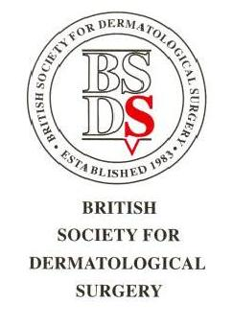

BSDS Medical Student Essay Prize

Conditions

- The BSDS Medical Student Essay Prize is open to any individual who has medical student status at the time of application or who graduates in 2024.

- Submissions must be the applicant’s own work and be on the subject determined by the BSDS Executive Committee. Submissions should take the format of:

- A PowerPoint lesson plan (maximum 3 slides)
- An instructional video (real life or computer animated - maximum 5 minutes)
- An artistic presentation (drawings/photographs/combination of) (Not PDF please)

- To apply, applicants should submit their essay and application form to: info@bsds.org.uk

- The deadline for applications will be 31st July 2024 at 11.59pm.

- The prize will be: £300.

- Winners may be invited to give a presentation at one of the BSDS meetings and will have their essay published on the BSDS website and social media.

- Applicants’ student status will be confirmed with the medical school before prize is awarded.

Marking Criteria

Your submission will be judged on the following criteria:

- Content (20)
- Originality (10)
- Style/Structure (10)
- Relevance to Dermatological Surgery (10)

