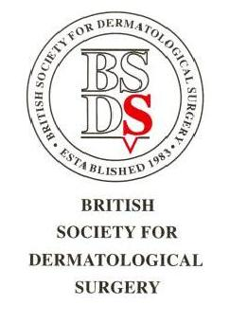
The British Society for Dermatological Surgery
Application for appointment to the Skills Faculty

(Consultant & SAS Doctors& Mohs Fellow)
Personal Details
Name

Address

Email Address

Best contact phone number

Are you a BSDS member?

GMC no.

Current Post
Date appointed to current post
Place of work

Personal Statement
Please provide a short statement as to why you feel you would be suitable for this role, demonstrating your interest in surgical training and education (~200 words)

To be completed by the Applicant
I confirm that I have attached my mini CV

I confirm that I have support from my Clinical Director
Name of Clinical Director

Application signature
Date

Please return the completed form with attachments to:
Executive Officer
British Society for Dermatological Society
info@bsds.org.uk

Any queries, please email info@bsds.og.uk

