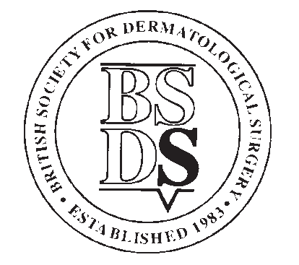
BRITISH SOCIETY FOR DERMATOLOGICAL SURGERY
Travelling Fellowship Award
(A Prospective Award)
Applicants Details
Surname
Forename
Current Status | Consultant |  | Derm Surgery Fellow
 | Registrar |  | Other (Please Specify)
Hospital Name

Contact Address
Post Code
Telephone
Email

Meeting or centre you wish to visit
Date of Meeting/Visit
Your aims and what you hope to achieve
If you are presenting a paper at a meeting, please give the title, type of presentation (oral or poster) and guide to content (original research or clinical/case report) for each paper
Applications made for other funding (whether granted or not)

Applications must be submitted along with your C.V. to info@bsds.org.uk
The closing date for applications is Wednesday 1st November 2023.

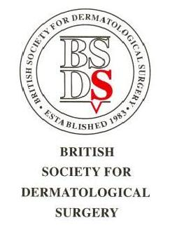

BSDS Travelling Fellowship Award

Conditions

- Travelling Fellowships are designed to assist BSDS members to participate in training in surgical dermatology. This could include attendance at specialist national or international meetings or courses, or attendance at a centre to learn a special technique. (prospectively)

- Fellowships are open to Ordinary and Trainee Members of the BSDS who are working in dermatology in the UK or Ireland.

- The BSDS reserves the right to vary the amounts and the conditions of the fellowships, or terminate the fellowships, in which case applicants will be notified.

- Applications can be made for only 1 meeting/course/visit, giving the estimated cost.

- Applicants travelling abroad must ensure that they have the necessary travel documents in place before funding will be granted.

- Any other funding applied for/received must be disclosed on the application form, and any funds subsequently received must be disclosed in the report upon completion of the fellowship.

- Judging will take into consideration the quality of the submitted CV in particular, evidence of academic excellence, innovation and research interest and commitment to a career in dermatological surgery. If the fellowship is to help fund attendance at a conference or meeting, judging will also be based on whether a presentation(s) is to be given at the meeting and whether this will be oral or poster and whether an additional visit/period of study will be made at a dermatological surgery centre.

- The closing date shall be the 1st November of each year. Applications received after this date will not be considered.

- Applicants will be judged approximately two weeks after the closing date.

- Any publications arising as a result of the award of a fellowship must give due acknowledgement to the BSDS fellowship.

- A typewritten report of up to 500 words must be submitted to the BSDS no later than 2 months after completion of the fellowship.

- The names of the fellowship winners will be published by the BSDS.

- The fellowship winners travelling report will be published on the BSDS website and may also be published in the BSDS newsletter and or podcast.

