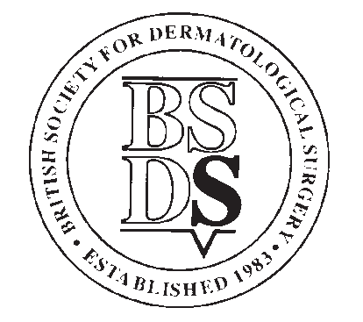
BRITISH SOCIETY FOR DERMATOLOGICAL SURGERY
Travelling Fellowship Award
(A Prospective Award)
Applicants Details
Surname
Forename
Current Status | Consultant |  | Derm Surgery Fellow
 | Registrar |  | Other (Please Specify)
Hospital Name

Contact Address
Post Code
Telephone
Email

Meeting or centre you wish to visit
Date of Meeting/Visit
Your aims and what you hope to achieve
If you are presenting a paper at a meeting, please give the title, type of presentation (oral or poster) and guide to content (original research or clinical/case report) for each paper
Applications made for other funding (whether granted or not)

Applications must be submitted along with your C.V. to info@bsds.org.uk
The closing date for applications is Tuesday 4th January 2022.

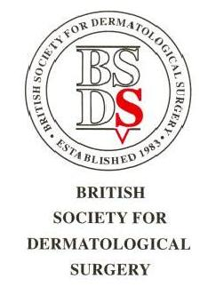

BSDS Travelling Fellowship Award

Conditions

- Travelling Fellowships are designed to assist BSDS members to participate in training in surgical dermatology. This could include attendance at specialist national or international meetings or courses, or attendance at a centre to learn a special technique. (prospectively)

- Fellowships are open to Ordinary and Trainee Members of the BSDS who are working in dermatology in the UK or Ireland.

- A maximum of 1 award of up to £2,500 can be made each year. The BSDS reserves the right to vary the amounts and the conditions of the fellowships, or terminate the fellowships, in which case applicants will be notified.

- Applications can be made for only 1 meeting/course/visit, giving the estimated cost.

- Applicants travelling abroad must ensure that they have the necessary travel documents in place before funding will be granted.

- Any other funding applied for/received must be disclosed on the application form, and any funds subsequently received must be disclosed in the report upon completion of the fellowship.

- Judging will take into consideration the quality of the submitted CV in particular; evidence of academic excellence, innovation and research interest and commitment to a career in dermatological surgery. If the fellowship is to help fund attendance at a conference or meeting, judging will also be based on whether a presentation(s) is to be given at the meeting and whether this will be oral or poster and whether an additional visit/period of study will be made at a dermatological surgery centre.

- The closing date shall be the 1st November of each year. Applications received after this date will not be considered.

- Applicants will be judged approximately two weeks after the closing date.

- Any publications arising as a result of the award of a fellowship must give due acknowledgement to the BSDS fellowship.

- A typewritten report of up to 500 words must be submitted to the BSDS no later than 2 months after completion of the fellowship.

- The names of the fellowship winners will be published by the BSDS.

- The fellowship winners travelling report will be published on the BSDS website and may also be published in the BSDS newsletter and or podcast.

